**Name: Aditya Gupta**

**Class: D15B**

**Roll: 19**

**Lab 5**

1. Go to<https://developer.hashicorp.com/terraform/install?product_intent=terraform>

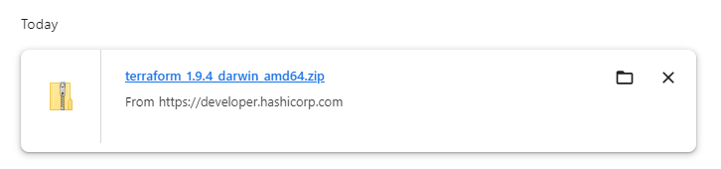

1. Download the file into C:/Terraform

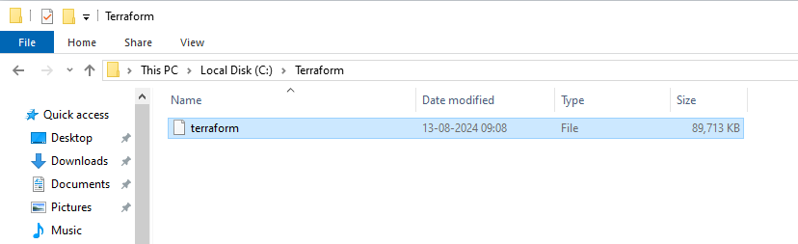

1. Add C:/Terraform in the environmental Variables

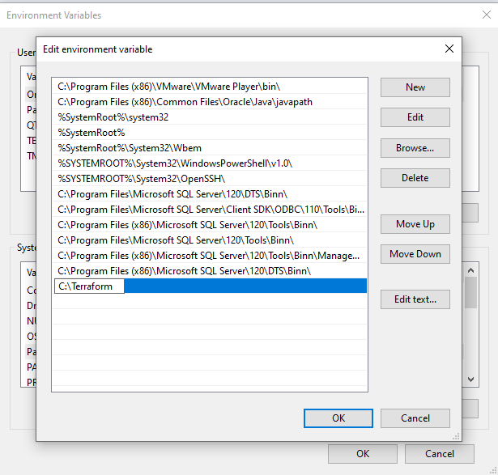

1. Go to CMD and type terraform to check

